Добрый день! Уважаемые читатели и гости одного из крупнейших IT блогов в рунете Pyatilistnik.org. В прошлый раз я вас научил [сохранять себе на компьютер защищенный от скачивания PDF файл в Google диске](https://pyatilistnik.org/download-view-protected-pdf-google-drive/). Мне неоднократно пишут в комментариях, что мог бы я вас научить делать все,  то же самое, но уже для Google документов. Ниже я вас научу скачивать защищенный от редактирования Google документ. Это так же не потребует от вас супер способностей. Давайте приступать. С вас за это подписка на мой телеграмм (https://t.me/pyatilistnikorg) канал и Youtube канал, чтобы не пропускать много интересного.

[[](https://yandex.ru/an/count/WR4ejI_zOoVX2Lc50HqD06DMLIOQbKgbKga4mGHzFfSxUxRVkVE6Er-_u_M6Ernbqpin08IWZD9hQ814MeS2CEWu-Z2KPA6KZYb-W3hRR-unbjBqziC8YIr6ShuK5Cr0f3Ho8jo6m2W5JmeRKG-4YLOVv92sAxwR7SS1KBHOMC5X_AgoyIxBQD8OjmgnJ151B7FfGeX5JCFLUVnIeGAuiH4CobYwfZykOaOmQ8iInMpOACagPoOiTeRiPAIpm-kA8JSPAE8LGL5BGmD5Idgq1FpWvwRU0cRaB_P3bl3zhn-oXEzx_P0bV9_hdHpPylT_LqJ9rpArOEpF_hiYIfXcc2NCifVCWAphkewbpJEAQKmIwKRcEVkbTnWww-iAiKnvCmtconaMs_0yMO0cZN5-J7lmJHbObqR_pT6i04BwBOxL0otFQwEBQKA-V7PPPY85TuEcpPLAfR8QJhlQz9FoFt0JT4WEBBeW6FmMUyN0EIrxNEi8g9mUyaOtP8u-kwzMsPiEjBW32CpzqPcbaTPws4buk7XnxMDQYyob-HaKKzXuCTk0u-agPG_CJ1pBtuMbUI0j~2?stat-id=7&test-tag=390326627916305&banner-sizes=eyI3MDAwNDM1NTU1IjoiNjE1eDI5NCJ9&format-type=118&actual-format=10&pcodever=834246&banner-test-tags=eyI3MDAwNDM1NTU1IjoiMjgxNDc5MjcxODY2NDE3In0%3D&constructor-rendered-assets=eyI3MDAwNDM1NTU1Ijo4ODQ1fQ&pcode-active-testids=815808%2C0%2C68&width=615&height=294&subDesignId=1000421000)](https://yandex.ru/an/count/WR4ejI_zOoVX2Lc50HqD06DMLIOQbKgbKga4mGHzFfSxUxRVkVE6Er-_u_M6Ernbqpin08IWZD9hQ814MeS2CEWu-Z2KPA6KZYb-W3hRR-unbjBqziC8YIr6ShuK5Cr0f3Ho8jo6m2W5JmeRKG-4YLOVv92sAxwR7SS1KBHOMC5X_AgoyIxBQD8OjmgnJ151B7FfGeX5JCFLUVnIeGAuiH4CobYwfZykOaOmQ8iInMpOACagPoOiTeRiPAIpm-kA8JSPAE8LGL5BGmD5Idgq1FpWvwRU0cRaB_P3bl3zhn-oXEzx_P0bV9_hdHpPylT_LqJ9rpArOEpF_hiYIfXcc2NCifVCWAphkewbpJEAQKmIwKRcEVkbTnWww-iAiKnvCmtconaMs_0yMO0cZN5-J7lmJHbObqR_pT6i04BwBOxL0otFQwEBQKA-V7PPPY85TuEcpPLAfR8QJhlQz9FoFt0JT4WEBBeW6FmMUyN0EIrxNEi8g9mUyaOtP8u-kwzMsPiEjBW32CpzqPcbaTPws4buk7XnxMDQYyob-HaKKzXuCTk0u-agPG_CJ1pBtuMbUI0j~2?stat-id=7&test-tag=390326627916305&banner-sizes=eyI3MDAwNDM1NTU1IjoiNjE1eDI5NCJ9&format-type=118&actual-format=10&pcodever=834246&banner-test-tags=eyI3MDAwNDM1NTU1IjoiMjgxNDc5MjcxODY2NDE3In0%3D&constructor-rendered-assets=eyI3MDAwNDM1NTU1Ijo4ODQ1fQ&pcode-active-testids=815808%2C0%2C68&width=615&height=294&subDesignId=1000421000" \t "_blank)

[[](https://yandex.ru/an/count/WR4ejI_zOoVX2Lc50HqD06DMLIOQbKgbKga4mGHzFfSxUxRVkVE6Er-_u_M6Ernbqpin08IWZD9hQ814MeS2CEWu-Z2KPA6KZYb-W3hRR-unbjBqziC8YIr6ShuK5Cr0f3Ho8jo6m2W5JmeRKG-4YLOVv92sAxwR7SS1KBHOMC5X_AgoyIxBQD8OjmgnJ151B7FfGeX5JCFLUVnIeGAuiH4CobYwfZykOaOmQ8iInMpOACagPoOiTeRiPAIpm-kA8JSPAE8LGL5BGmD5Idgq1FpWvwRU0cRaB_P3bl3zhn-oXEzx_P0bV9_hdHpPylT_LqJ9rpArOEpF_hiYIfXcc2NCifVCWAphkewbpJEAQKmIwKRcEVkbTnWww-iAiKnvCmtconaMs_0yMO0cZN5-J7lmJHbObqR_pT6i04BwBOxL0otFQwEBQKA-V7PPPY85TuEcpPLAfR8QJhlQz9FoFt0JT4WEBBeW6FmMUyN0EIrxNEi8g9mUyaOtP8u-kwzMsPiEjBW32CpzqPcbaTPws4buk7XnxMDQYyob-HaKKzXuCTk0u-agPG_CJ1pBtuMbUI0j~2?stat-id=7&test-tag=390326627916305&banner-sizes=eyI3MDAwNDM1NTU1IjoiNjE1eDI5NCJ9&format-type=118&actual-format=10&pcodever=834246&banner-test-tags=eyI3MDAwNDM1NTU1IjoiMjgxNDc5MjcxODY2NDE3In0%3D&constructor-rendered-assets=eyI3MDAwNDM1NTU1Ijo4ODQ1fQ&pcode-active-testids=815808%2C0%2C68&width=615&height=294&subDesignId=1000421000)](https://yandex.ru/an/count/WR4ejI_zOoVX2Lc50HqD06DMLIOQbKgbKga4mGHzFfSxUxRVkVE6Er-_u_M6Ernbqpin08IWZD9hQ814MeS2CEWu-Z2KPA6KZYb-W3hRR-unbjBqziC8YIr6ShuK5Cr0f3Ho8jo6m2W5JmeRKG-4YLOVv92sAxwR7SS1KBHOMC5X_AgoyIxBQD8OjmgnJ151B7FfGeX5JCFLUVnIeGAuiH4CobYwfZykOaOmQ8iInMpOACagPoOiTeRiPAIpm-kA8JSPAE8LGL5BGmD5Idgq1FpWvwRU0cRaB_P3bl3zhn-oXEzx_P0bV9_hdHpPylT_LqJ9rpArOEpF_hiYIfXcc2NCifVCWAphkewbpJEAQKmIwKRcEVkbTnWww-iAiKnvCmtconaMs_0yMO0cZN5-J7lmJHbObqR_pT6i04BwBOxL0otFQwEBQKA-V7PPPY85TuEcpPLAfR8QJhlQz9FoFt0JT4WEBBeW6FmMUyN0EIrxNEi8g9mUyaOtP8u-kwzMsPiEjBW32CpzqPcbaTPws4buk7XnxMDQYyob-HaKKzXuCTk0u-agPG_CJ1pBtuMbUI0j~2?stat-id=7&test-tag=390326627916305&banner-sizes=eyI3MDAwNDM1NTU1IjoiNjE1eDI5NCJ9&format-type=118&actual-format=10&pcodever=834246&banner-test-tags=eyI3MDAwNDM1NTU1IjoiMjgxNDc5MjcxODY2NDE3In0%3D&constructor-rendered-assets=eyI3MDAwNDM1NTU1Ijo4ODQ1fQ&pcode-active-testids=815808%2C0%2C68&width=615&height=294&subDesignId=1000421000" \t "_blank)

[konovalov-eye-center.ru](https://yandex.ru/an/count/WR4ejI_zOoVX2Lc50HqD06DMLIOQbKgbKga4mGHzFfSxUxRVkVE6Er-_u_M6Ernbqpin08IWZD9hQ814MeS2CEWu-Z2KPA6KZYb-W3hRR-unbjBqziC8YIr6ShuK5Cr0f3Ho8jo6m2W5JmeRKG-4YLOVv92sAxwR7SS1KBHOMC5X_AgoyIxBQD8OjmgnJ151B7FfGeX5JCFLUVnIeGAuiH4CobYwfZykOaOmQ8iInMpOACagPoOiTeRiPAIpm-kA8JSPAE8LGL5BGmD5Idgq1FpWvwRU0cRaB_P3bl3zhn-oXEzx_P0bV9_hdHpPylT_LqJ9rpArOEpF_hiYIfXcc2NCifVCWAphkewbpJEAQKmIwKRcEVkbTnWww-iAiKnvCmtconaMs_0yMO0cZN5-J7lmJHbObqR_pT6i04BwBOxL0otFQwEBQKA-V7PPPY85TuEcpPLAfR8QJhlQz9FoFt0JT4WEBBeW6FmMUyN0EIrxNEi8g9mUyaOtP8u-kwzMsPiEjBW32CpzqPcbaTPws4buk7XnxMDQYyob-HaKKzXuCTk0u-agPG_CJ1pBtuMbUI0j~2?stat-id=7&test-tag=390326627916305&banner-sizes=eyI3MDAwNDM1NTU1IjoiNjE1eDI5NCJ9&format-type=118&actual-format=10&pcodever=834246&banner-test-tags=eyI3MDAwNDM1NTU1IjoiMjgxNDc5MjcxODY2NDE3In0%3D&constructor-rendered-assets=eyI3MDAwNDM1NTU1Ijo4ODQ1fQ&pcode-active-testids=815808%2C0%2C68&width=615&height=294&subDesignId=1000421000" \t "_blank)

РЕКЛАМА

**[Записаться к ведущему офтальмологу!](https://yandex.ru/an/count/WR4ejI_zOoVX2Lc50HqD06DMLIOQbKgbKga4mGHzFfSxUxRVkVE6Er-_u_M6Ernbqpin08IWZD9hQ814MeS2CEWu-Z2KPA6KZYb-W3hRR-unbjBqziC8YIr6ShuK5Cr0f3Ho8jo6m2W5JmeRKG-4YLOVv92sAxwR7SS1KBHOMC5X_AgoyIxBQD8OjmgnJ151B7FfGeX5JCFLUVnIeGAuiH4CobYwfZykOaOmQ8iInMpOACagPoOiTeRiPAIpm-kA8JSPAE8LGL5BGmD5Idgq1FpWvwRU0cRaB_P3bl3zhn-oXEzx_P0bV9_hdHpPylT_LqJ9rpArOEpF_hiYIfXcc2NCifVCWAphkewbpJEAQKmIwKRcEVkbTnWww-iAiKnvCmtconaMs_0yMO0cZN5-J7lmJHbObqR_pT6i04BwBOxL0otFQwEBQKA-V7PPPY85TuEcpPLAfR8QJhlQz9FoFt0JT4WEBBeW6FmMUyN0EIrxNEi8g9mUyaOtP8u-kwzMsPiEjBW32CpzqPcbaTPws4buk7XnxMDQYyob-HaKKzXuCTk0u-agPG_CJ1pBtuMbUI0j~2?stat-id=7&test-tag=390326627916305&banner-sizes=eyI3MDAwNDM1NTU1IjoiNjE1eDI5NCJ9&format-type=118&actual-format=10&pcodever=834246&banner-test-tags=eyI3MDAwNDM1NTU1IjoiMjgxNDc5MjcxODY2NDE3In0%3D&constructor-rendered-assets=eyI3MDAwNDM1NTU1Ijo4ODQ1fQ&pcode-active-testids=815808%2C0%2C68&width=615&height=294&subDesignId=1000421000" \t "_blank)**

[Современное оборудование передовые методы лечения. Опыт более 20 лет! Звоните!](https://yandex.ru/an/count/WR4ejI_zOoVX2Lc50HqD06DMLIOQbKgbKga4mGHzFfSxUxRVkVE6Er-_u_M6Ernbqpin08IWZD9hQ814MeS2CEWu-Z2KPA6KZYb-W3hRR-unbjBqziC8YIr6ShuK5Cr0f3Ho8jo6m2W5JmeRKG-4YLOVv92sAxwR7SS1KBHOMC5X_AgoyIxBQD8OjmgnJ151B7FfGeX5JCFLUVnIeGAuiH4CobYwfZykOaOmQ8iInMpOACagPoOiTeRiPAIpm-kA8JSPAE8LGL5BGmD5Idgq1FpWvwRU0cRaB_P3bl3zhn-oXEzx_P0bV9_hdHpPylT_LqJ9rpArOEpF_hiYIfXcc2NCifVCWAphkewbpJEAQKmIwKRcEVkbTnWww-iAiKnvCmtconaMs_0yMO0cZN5-J7lmJHbObqR_pT6i04BwBOxL0otFQwEBQKA-V7PPPY85TuEcpPLAfR8QJhlQz9FoFt0JT4WEBBeW6FmMUyN0EIrxNEi8g9mUyaOtP8u-kwzMsPiEjBW32CpzqPcbaTPws4buk7XnxMDQYyob-HaKKzXuCTk0u-agPG_CJ1pBtuMbUI0j~2?stat-id=7&test-tag=390326627916305&banner-sizes=eyI3MDAwNDM1NTU1IjoiNjE1eDI5NCJ9&format-type=118&actual-format=10&pcodever=834246&banner-test-tags=eyI3MDAwNDM1NTU1IjoiMjgxNDc5MjcxODY2NDE3In0%3D&constructor-rendered-assets=eyI3MDAwNDM1NTU1Ijo4ODQ1fQ&pcode-active-testids=815808%2C0%2C68&width=615&height=294&subDesignId=1000421000" \t "_blank)

[|Акции и скидки](https://yandex.ru/an/count/WR4ejI_zOoVX2Lc50HqD06DMLIOQbKgbKga4mGHzFfSxUxRVkVE6Er-_u_M6Ernbqpin08IWZD9hQ814MeS2CEWu-Z2KPA6KZYb-W3hRR-unbjBqziC8YIr6ShuK5Cr0f3Ho8jo6m2W5JmeRKG-4YLOVv92sAxwR7SS1KBHOMC5X_AgoyIxBQD8OjmgnJ151B7FfGeX5JCFLUVnIeGAuiH4CobYwfZykOaOmQ8iInMpOACagPoOiTeRiPAIpm-kA8JSPAE8LGL5BGmD5Idgq1FpWvwRU0cRaB_P3bl3zhn-oXEzx_P0bV9_hdHpPylT_LqJ9rpArOEpF_hiYIfXcc2NCifVCWAphkewbpJEAQKmIwKRcEVkbTnWww-iAiKnvCmtconaMs_0yMO0cZN5-t807tvI1TMdqtnpD2Y2at-9OFT3ol3Qwc2RaosUNPIPIS3TesbofL2ghuRIhJJyflmRDG2uviEY26FmMUyN0EIrxNEi8g9mUyaOtP8u-kwzMsPiEjBW32CpzqPcbaTPws4buk7XnxMDQYyob-HaKKzXuCTk0u-agPG_CJ1pBtuMbUI0j~2?stat-id=7&test-tag=390326627916305&banner-sizes=eyI3MDAwNDM1NTU1IjoiNjE1eDI5NCJ9&format-type=118&actual-format=10&pcodever=834246&banner-test-tags=eyI3MDAwNDM1NTU1IjoiMjgxNDc5MjcxODY2NDE3In0%3D&constructor-rendered-assets=eyI3MDAwNDM1NTU1Ijo4ODQ1fQ&pcode-active-testids=815808%2C0%2C68&width=615&height=294&subDesignId=1000421000" \t "_blank)

[|Онлайн запись](https://yandex.ru/an/count/WR4ejI_zOoVX2Lc50HqD06DMLIOQbKgbKga4mGHzFfSxUxRVkVE6Er-_u_M6Ernbqpin08IWZD9hQ814MeS2CEWu-Z2KPA6KZYb-W3hRR-unbjBqziC8YIr6ShuK5Cr0f3Ho8jo6m2W5JmeRKG-4YLOVv92sAxwR7SS1KBHOMC5X_AgoyIxBQD8OjmgnJ151B7FfGeX5JCFLUVnIeGAuiH4CobYwfZykOaOmQ8iInMpOACagPoOiTeRiPAIpm-kA8JSPAE8LGL5BGmD5Idgq1FpWvwRU0cRaB_P3bl3zhn-oXEzx_P0bV9_hdHpPylT_LqJ9rpArOEpF_hiYIfXcc2NCifVCWAphkewbpJEAQKmIwKRcEVkbTnWww-iAiKnvCmtconaMs_0yMO0cZN5-xEF1DsLWNHhzDqUp0WZfjpXM3xGyhuqkfWdvyjbbcOaKt0sQDbSgbSfgEErgqq_AZtLXMKCEBBeW6FmMUyN0EIrxNEi8g9mUyaOtP8u-kwzMsPiEjBW32CpzqPcbaTPws4buk7XnxMDQYyob-HaKKzXuCTk0u-agPG_CJ1pBtuMbUI0j~2?stat-id=7&test-tag=390326627916305&banner-sizes=eyI3MDAwNDM1NTU1IjoiNjE1eDI5NCJ9&format-type=118&actual-format=10&pcodever=834246&banner-test-tags=eyI3MDAwNDM1NTU1IjoiMjgxNDc5MjcxODY2NDE3In0%3D&constructor-rendered-assets=eyI3MDAwNDM1NTU1Ijo4ODQ1fQ&pcode-active-testids=815808%2C0%2C68&width=615&height=294&subDesignId=1000421000" \t "_blank)

[|Задать вопрос врачу](https://yandex.ru/an/count/WR8ejI_zOoVX2Lc50IKD06EMLIOQbKgbKga4mGHzFfSxUxRVkVE6Er-_u_M6Ernbqpin08IWZD9hQ814MeS2CEWu-Z2KPA6KZYb-W3hRR-unbjBqziC8YIr6ShuK5Cr0f3Ho8jo6m2W5JmeRKG-4YLOVv92sAxwR7SS1KBHOMC5X_AgoyIxBQD8OjmgnJ151B7FfGeX5JCFLUVnIeGAuiH4CobYwfZykOaOmQ8iInMpOACagPoOiTeRiPAIpm-kA8JSPAE8LGL5BGmD5Idgq1FpWvwRU0cRaB_P3bl3zhn-oXEzx_P0bV9_hdHpPylT_LqJ9rpArOEpF_hiYIfXcc2NCifVCWAphkewbpJEAQKmIwKRcEVkbTnWww-iAiKnvCmtconaMs_0yMO0cZN5-hCA3Ryh0kZJwRuvc1H3IRt6i7cXvNXjTJ1FovRFBCXCfk1iqRQvKAfNLSDhLff-Ktzh0N0boOD450HZy5dl5m3ajUrph2AYS7l96DsIEFhklLjcR3hIu0mZC_T6PfP7MUjX9UBXuSUrZMelCfVaP55FOU37RWEFfAcKFp4mSoz-5fNaWBG00~2?stat-id=7&test-tag=390326627916305&banner-sizes=eyI3MDAwNDM1NTU1IjoiNjE1eDI5NCJ9&format-type=118&actual-format=10&pcodever=834246&banner-test-tags=eyI3MDAwNDM1NTU1IjoiMjgxNDc5MjcxODY2NDE3In0%3D&constructor-rendered-assets=eyI3MDAwNDM1NTU1Ijo4ODQ1fQ&pcode-active-testids=815808%2C0%2C68&width=615&height=294&subDesignId=1000421000" \t "_blank)

[|Мы Вам позвоним](https://yandex.ru/an/count/WRCejI_zOoVX2Lc50IqD07FMLIOQbKgbKga4mGHzFfSxUxRVkVE6Er-_u_M6Ernbqpin08IWZD9hQ814MeS2CEWu-Z2KPA6KZYb-W3hRR-unbjBqziC8YIr6ShuK5Cr0f3Ho8jo6m2W5JmeRKG-4YLOVv92sAxwR7SS1KBHOMC5X_AgoyIxBQD8OjmgnJ6qWWbZcqeKGYvY6g_FufK85S6CZ69InT4r_NCICOD0M9OhPi56ILSvCMEmCsSb8PuVN5KDkCb34AuAYbeO6YfJqQ0dumSzDlGNCo5_iXopX-ry_P0dVz_eXI_W-rpivikNl_ww8agzbQi7Od_rtHPGmpJ1Bc6KlcG5PrtKTIvjd5DEO9DADp7FsI-ymTDRN5MAPycOQp9SpBBRXUR80JHhZ_1Y61z-KWNLfzDySpGeWfD_YM3tGyhmskfWcvCjdbsKcKd0tQDfSgLGgg-6qgqq_AVzN5mUuo8555mGO_1PxnS0vBNjSwmYed1xoHZTaZZwxhrRPcmwqk0CeTk3ip5AsjTve4XuoN5prcDOYvf9-1iKUDbxSDk1uSPMo1sucZk9tOMdkIGi0~2?stat-id=7&test-tag=390326627916305&banner-sizes=eyI3MDAwNDM1NTU1IjoiNjE1eDI5NCJ9&format-type=118&actual-format=10&pcodever=834246&banner-test-tags=eyI3MDAwNDM1NTU1IjoiMjgxNDc5MjcxODY2NDE3In0%3D&constructor-rendered-assets=eyI3MDAwNDM1NTU1Ijo4ODQ1fQ&pcode-active-testids=815808%2C0%2C68&width=615&height=294&subDesignId=1000421000" \t "_blank)

[Узнать больше](https://yandex.ru/an/count/WR4ejI_zOoVX2Lc50HqD06DMLIOQbKgbKga4mGHzFfSxUxRVkVE6Er-_u_M6Ernbqpin08IWZD9hQ814MeS2CEWu-Z2KPA6KZYb-W3hRR-unbjBqziC8YIr6ShuK5Cr0f3Ho8jo6m2W5JmeRKG-4YLOVv92sAxwR7SS1KBHOMC5X_AgoyIxBQD8OjmgnJ151B7FfGeX5JCFLUVnIeGAuiH4CobYwfZykOaOmQ8iInMpOACagPoOiTeRiPAIpm-kA8JSPAE8LGL5BGmD5Idgq1FpWvwRU0cRaB_P3bl3zhn-oXEzx_P0bV9_hdHpPylT_LqJ9rpArOEpF_hiYIfXcc2NCifVCWAphkewbpJEAQKmIwKRcEVkbTnWww-iAiKnvCmtconaMs_0yMO0cZN5-J7lmJHbObqR_pT6i04BwBOxL0otFQwEBQKA-V7PPPY85TuEcpPLAfR8QJhlQz9FoFt0JT4WEBBeW6FmMUyN0EIrxNEi8g9mUyaOtP8u-kwzMsPiEjBW32CpzqPcbaTPws4buk7XnxMDQYyob-HaKKzXuCTk0u-agPG_CJ1pBtuMbUI0j~2?stat-id=7&test-tag=390326627916305&banner-sizes=eyI3MDAwNDM1NTU1IjoiNjE1eDI5NCJ9&format-type=118&actual-format=10&pcodever=834246&banner-test-tags=eyI3MDAwNDM1NTU1IjoiMjgxNDc5MjcxODY2NDE3In0%3D&constructor-rendered-assets=eyI3MDAwNDM1NTU1Ijo4ODQ1fQ&pcode-active-testids=815808%2C0%2C68&width=615&height=294&subDesignId=1000421000)

ЕСТЬ ПРОТИВОПОКАЗАНИЯ. ПОСОВЕТУЙТЕСЬ С ВРАЧОМ

Написала мне подписчица по имени Вероника:

Здравствуйте, умоляю Вас, помогите пожалуйста!  
Если вас не затруднит, подскажите, каким образом можно скачать защищенный docs. файл или хотя бы скопировать текст? Т.Т  
сам файл лежит в «гугл документах», вот ссылка:  
https://docs.google.com/document/d/1WauyboAQIE0mC1iUAcpHKXKd3AT64XV6nKntchGLaXw/edit

Как я и писал выше, меня много раз об этом просили. Чтобы людям было проще и не отвечать об этом каждому отдельно, вот вам подробная инструкция, как сохранить на компьютер защищенный Гугл документ.

В пример есть ссылка, которая заканчивается на **/edit**.

[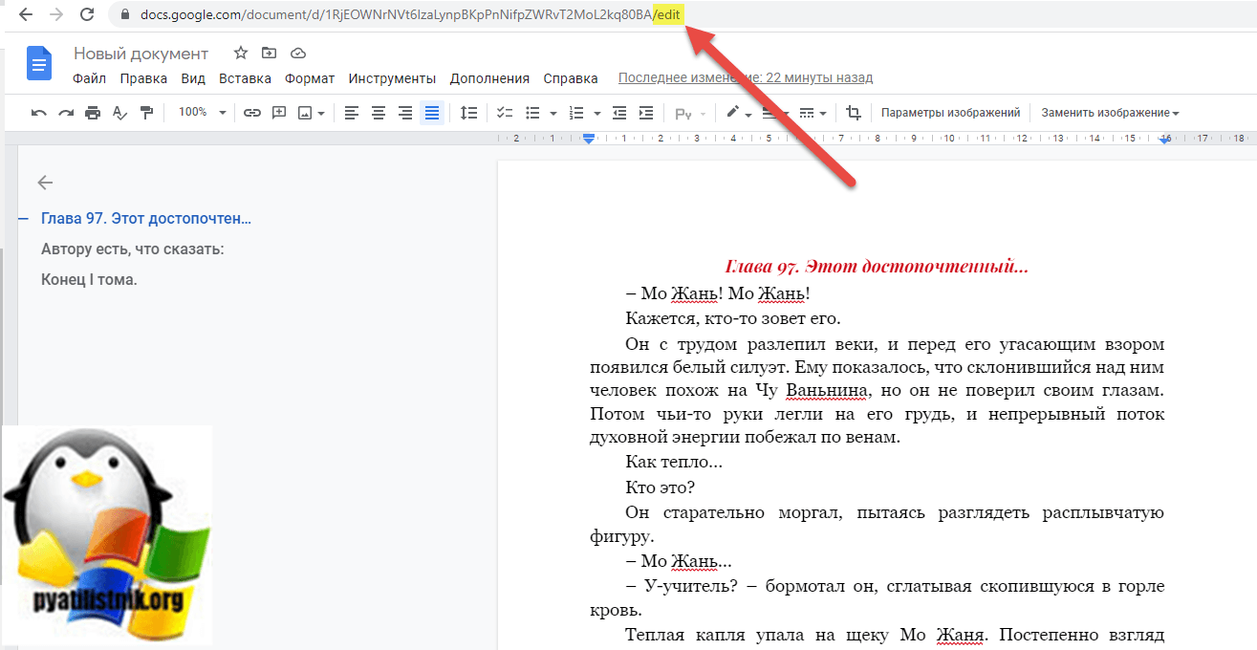](https://pyatilistnik.org/wp-content/uploads/2021/11/google-protected-document.png)

Первое, что вы должны сделать, это поменять **/edit**на **/mobilebasic**и нажать **Enter.**

[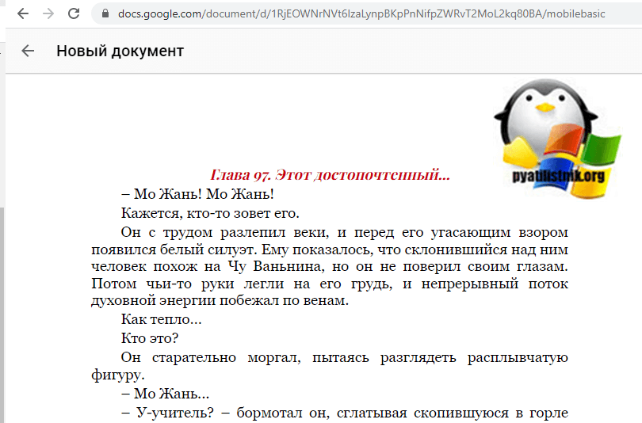](https://pyatilistnik.org/wp-content/uploads/2021/11/google-document-in-mobilebasic-mode.png)

Как видите страница поменяла стиль и вы уже здесь сможете выделять текст и его копировать. теперь нажмите сочетание клавиш **CTRL** и **A** одновременно. В результате вы выделите в данном документе все его содержимое.

[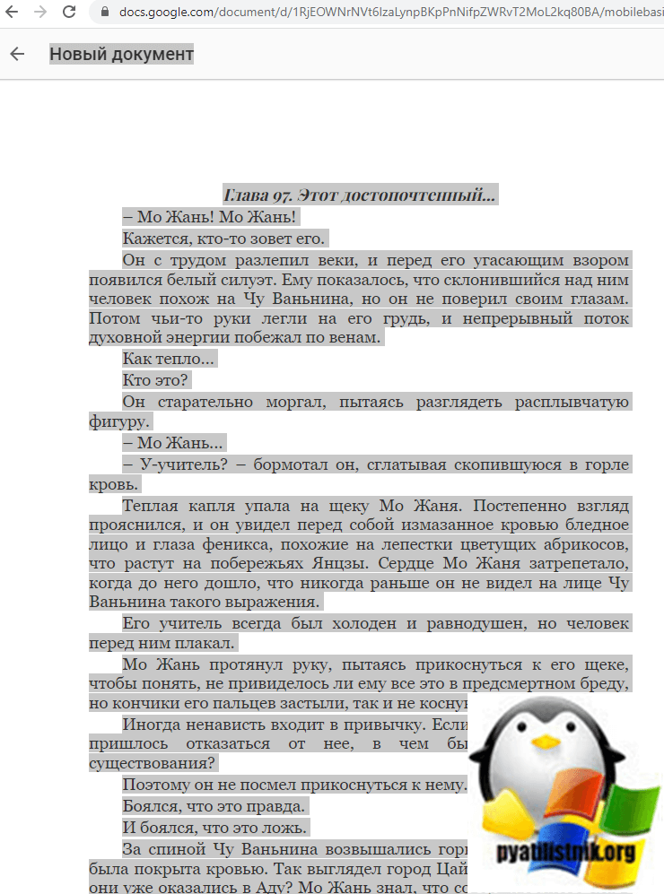](https://pyatilistnik.org/wp-content/uploads/2021/11/selecting-text-from-a-protected-document-in-google.png)

Теперь создайте новый документ в Google или просто в Word и вставьте скопированный, выделенный текст туда. В подавляющем числе случаев, там даже сохранится форматирование.

[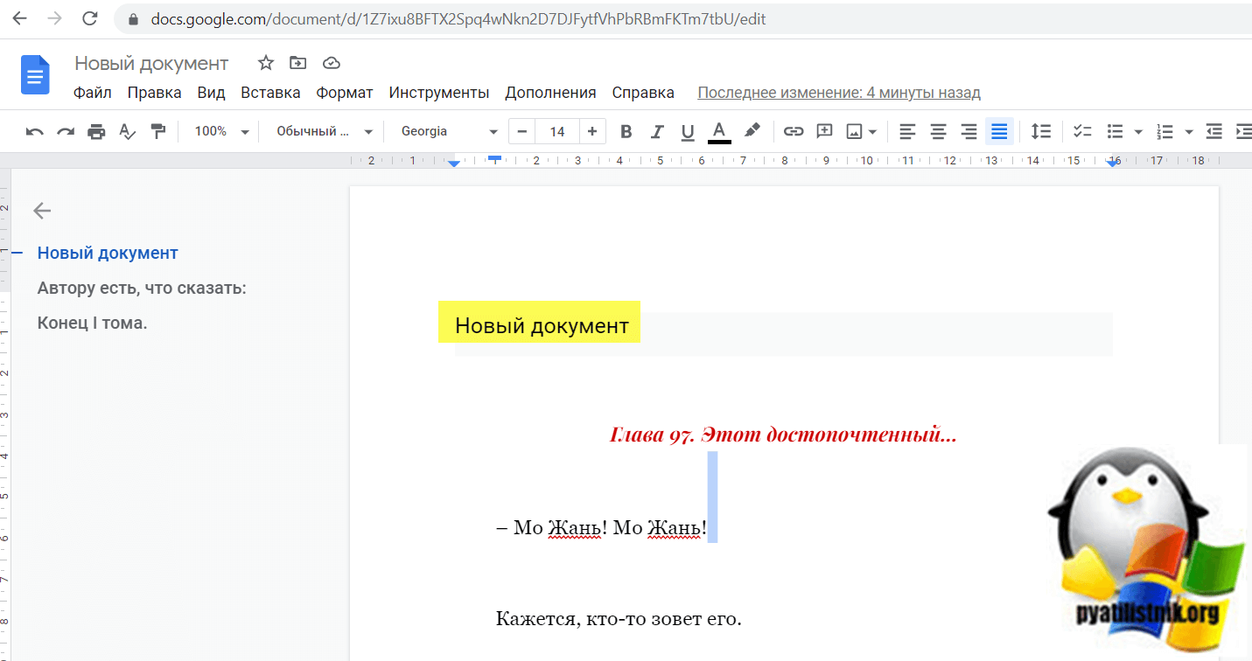](https://pyatilistnik.org/wp-content/uploads/2021/11/successful-upload-of-a-protected-document-to-google.png)

[[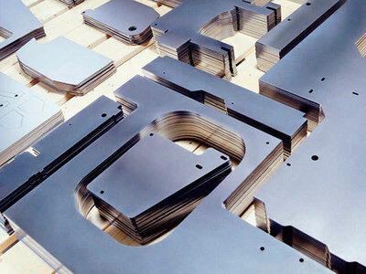](https://yandex.ru/an/count/WTaejI_zOoVX2LcE0LqE07FPOIOQbKgbKga4mGHzFfSxUxRVkVDTNpjVl-FrXZjSPTCxgRruWj9hQ42ACl0CWuwZZxhYtGktkenywMmjYBiuGHCVEeP9R36IypLn64G1jaUI0EHqPGooxP3Io8bwhZHWsE19OICwWuFrOsraBsex6HVlZHVo2fmaBKa79dM8DjvbsOGDN1qglImeO2Jq-NdLY1tGTLslqJV8yL5r_L0owQNXwZn-gL01tDW81Yy6PInTqnyNCICOj4M9OZPib6ILCnCJ5Zj3TZBIOO3YOog6t6IW21938r0D3HGfwT4Iy8EVcte5P0b-iS-Z0kI7cpmatpvuHcBZ_yv8RFpU6OcDdmi0moj_NtO1oVfQEakLl9zTTW79Offfd9Zb71cGTLtNiRIv-UH95IgwSSDRsPRUO-YihoE40kRDIp5V7W0lBS-JFNSkFCNLuyz_Eu0SNnb3Zg-KlTRxg3E4olDPchwo9oYqiNs7rpqJAaUof0LooVeDcZPNAfNAQZWjRDDKok-5800Ax4ugFm4M_1vxLG0R-LlXcaMIZX-UY3AIc8PVEpNMZJ1Yl14jljpp4PurIVHGkvGezZo-5xU60OAKUPa0AKkdKDshXFFwE000~2?stat-id=8&test-tag=390326627916305&banner-sizes=eyI3MjA1NzYwNjUxMDQxODgwNCI6IjYxNXgzMDAifQ%3D%3D&format-type=118&actual-format=10&pcodever=834246&banner-test-tags=eyI3MjA1NzYwNjUxMDQxODgwNCI6IjI4MTQ3OTI3MTg2NjM4NSJ9&constructor-rendered-assets=eyI3MjA1NzYwNjUxMDQxODgwNCI6MTA1NzQyMX0&pcode-active-testids=815808%2C0%2C68&width=615&height=300&subDesignId=1000421000)](https://yandex.ru/an/count/WTaejI_zOoVX2LcE0LqE07FPOIOQbKgbKga4mGHzFfSxUxRVkVDTNpjVl-FrXZjSPTCxgRruWj9hQ42ACl0CWuwZZxhYtGktkenywMmjYBiuGHCVEeP9R36IypLn64G1jaUI0EHqPGooxP3Io8bwhZHWsE19OICwWuFrOsraBsex6HVlZHVo2fmaBKa79dM8DjvbsOGDN1qglImeO2Jq-NdLY1tGTLslqJV8yL5r_L0owQNXwZn-gL01tDW81Yy6PInTqnyNCICOj4M9OZPib6ILCnCJ5Zj3TZBIOO3YOog6t6IW21938r0D3HGfwT4Iy8EVcte5P0b-iS-Z0kI7cpmatpvuHcBZ_yv8RFpU6OcDdmi0moj_NtO1oVfQEakLl9zTTW79Offfd9Zb71cGTLtNiRIv-UH95IgwSSDRsPRUO-YihoE40kRDIp5V7W0lBS-JFNSkFCNLuyz_Eu0SNnb3Zg-KlTRxg3E4olDPchwo9oYqiNs7rpqJAaUof0LooVeDcZPNAfNAQZWjRDDKok-5800Ax4ugFm4M_1vxLG0R-LlXcaMIZX-UY3AIc8PVEpNMZJ1Yl14jljpp4PurIVHGkvGezZo-5xU60OAKUPa0AKkdKDshXFFwE000~2?stat-id=8&test-tag=390326627916305&banner-sizes=eyI3MjA1NzYwNjUxMDQxODgwNCI6IjYxNXgzMDAifQ%3D%3D&format-type=118&actual-format=10&pcodever=834246&banner-test-tags=eyI3MjA1NzYwNjUxMDQxODgwNCI6IjI4MTQ3OTI3MTg2NjM4NSJ9&constructor-rendered-assets=eyI3MjA1NzYwNjUxMDQxODgwNCI6MTA1NzQyMX0&pcode-active-testids=815808%2C0%2C68&width=615&height=300&subDesignId=1000421000" \t "_blank)

[[](https://yandex.ru/an/count/WTaejI_zOoVX2LcE0LqE07FPOIOQbKgbKga4mGHzFfSxUxRVkVDTNpjVl-FrXZjSPTCxgRruWj9hQ42ACl0CWuwZZxhYtGktkenywMmjYBiuGHCVEeP9R36IypLn64G1jaUI0EHqPGooxP3Io8bwhZHWsE19OICwWuFrOsraBsex6HVlZHVo2fmaBKa79dM8DjvbsOGDN1qglImeO2Jq-NdLY1tGTLslqJV8yL5r_L0owQNXwZn-gL01tDW81Yy6PInTqnyNCICOj4M9OZPib6ILCnCJ5Zj3TZBIOO3YOog6t6IW21938r0D3HGfwT4Iy8EVcte5P0b-iS-Z0kI7cpmatpvuHcBZ_yv8RFpU6OcDdmi0moj_NtO1oVfQEakLl9zTTW79Offfd9Zb71cGTLtNiRIv-UH95IgwSSDRsPRUO-YihoE40kRDIp5V7W0lBS-JFNSkFCNLuyz_Eu0SNnb3Zg-KlTRxg3E4olDPchwo9oYqiNs7rpqJAaUof0LooVeDcZPNAfNAQZWjRDDKok-5800Ax4ugFm4M_1vxLG0R-LlXcaMIZX-UY3AIc8PVEpNMZJ1Yl14jljpp4PurIVHGkvGezZo-5xU60OAKUPa0AKkdKDshXFFwE000~2?stat-id=8&test-tag=390326627916305&banner-sizes=eyI3MjA1NzYwNjUxMDQxODgwNCI6IjYxNXgzMDAifQ%3D%3D&format-type=118&actual-format=10&pcodever=834246&banner-test-tags=eyI3MjA1NzYwNjUxMDQxODgwNCI6IjI4MTQ3OTI3MTg2NjM4NSJ9&constructor-rendered-assets=eyI3MjA1NzYwNjUxMDQxODgwNCI6MTA1NzQyMX0&pcode-active-testids=815808%2C0%2C68&width=615&height=300&subDesignId=1000421000)](https://yandex.ru/an/count/WTaejI_zOoVX2LcE0LqE07FPOIOQbKgbKga4mGHzFfSxUxRVkVDTNpjVl-FrXZjSPTCxgRruWj9hQ42ACl0CWuwZZxhYtGktkenywMmjYBiuGHCVEeP9R36IypLn64G1jaUI0EHqPGooxP3Io8bwhZHWsE19OICwWuFrOsraBsex6HVlZHVo2fmaBKa79dM8DjvbsOGDN1qglImeO2Jq-NdLY1tGTLslqJV8yL5r_L0owQNXwZn-gL01tDW81Yy6PInTqnyNCICOj4M9OZPib6ILCnCJ5Zj3TZBIOO3YOog6t6IW21938r0D3HGfwT4Iy8EVcte5P0b-iS-Z0kI7cpmatpvuHcBZ_yv8RFpU6OcDdmi0moj_NtO1oVfQEakLl9zTTW79Offfd9Zb71cGTLtNiRIv-UH95IgwSSDRsPRUO-YihoE40kRDIp5V7W0lBS-JFNSkFCNLuyz_Eu0SNnb3Zg-KlTRxg3E4olDPchwo9oYqiNs7rpqJAaUof0LooVeDcZPNAfNAQZWjRDDKok-5800Ax4ugFm4M_1vxLG0R-LlXcaMIZX-UY3AIc8PVEpNMZJ1Yl14jljpp4PurIVHGkvGezZo-5xU60OAKUPa0AKkdKDshXFFwE000~2?stat-id=8&test-tag=390326627916305&banner-sizes=eyI3MjA1NzYwNjUxMDQxODgwNCI6IjYxNXgzMDAifQ%3D%3D&format-type=118&actual-format=10&pcodever=834246&banner-test-tags=eyI3MjA1NzYwNjUxMDQxODgwNCI6IjI4MTQ3OTI3MTg2NjM4NSJ9&constructor-rendered-assets=eyI3MjA1NzYwNjUxMDQxODgwNCI6MTA1NzQyMX0&pcode-active-testids=815808%2C0%2C68&width=615&height=300&subDesignId=1000421000" \t "_blank)

[vt-metall.com](https://yandex.ru/an/count/WTaejI_zOoVX2LcE0LqE07FPOIOQbKgbKga4mGHzFfSxUxRVkVDTNpjVl-FrXZjSPTCxgRruWj9hQ42ACl0CWuwZZxhYtGktkenywMmjYBiuGHCVEeP9R36IypLn64G1jaUI0EHqPGooxP3Io8bwhZHWsE19OICwWuFrOsraBsex6HVlZHVo2fmaBKa79dM8DjvbsOGDN1qglImeO2Jq-NdLY1tGTLslqJV8yL5r_L0owQNXwZn-gL01tDW81Yy6PInTqnyNCICOj4M9OZPib6ILCnCJ5Zj3TZBIOO3YOog6t6IW21938r0D3HGfwT4Iy8EVcte5P0b-iS-Z0kI7cpmatpvuHcBZ_yv8RFpU6OcDdmi0moj_NtO1oVfQEakLl9zTTW79Offfd9Zb71cGTLtNiRIv-UH95IgwSSDRsPRUO-YihoE40kRDIp5V7W0lBS-JFNSkFCNLuyz_Eu0SNnb3Zg-KlTRxg3E4olDPchwo9oYqiNs7rpqJAaUof0LooVeDcZPNAfNAQZWjRDDKok-5800Ax4ugFm4M_1vxLG0R-LlXcaMIZX-UY3AIc8PVEpNMZJ1Yl14jljpp4PurIVHGkvGezZo-5xU60OAKUPa0AKkdKDshXFFwE000~2?stat-id=8&test-tag=390326627916305&banner-sizes=eyI3MjA1NzYwNjUxMDQxODgwNCI6IjYxNXgzMDAifQ%3D%3D&format-type=118&actual-format=10&pcodever=834246&banner-test-tags=eyI3MjA1NzYwNjUxMDQxODgwNCI6IjI4MTQ3OTI3MTg2NjM4NSJ9&constructor-rendered-assets=eyI3MjA1NzYwNjUxMDQxODgwNCI6MTA1NzQyMX0&pcode-active-testids=815808%2C0%2C68&width=615&height=300&subDesignId=1000421000" \t "_blank)

РЕКЛАМА

**[Не заказывайте лазерную резку металла!](https://yandex.ru/an/count/WTaejI_zOoVX2LcE0LqE07FPOIOQbKgbKga4mGHzFfSxUxRVkVDTNpjVl-FrXZjSPTCxgRruWj9hQ42ACl0CWuwZZxhYtGktkenywMmjYBiuGHCVEeP9R36IypLn64G1jaUI0EHqPGooxP3Io8bwhZHWsE19OICwWuFrOsraBsex6HVlZHVo2fmaBKa79dM8DjvbsOGDN1qglImeO2Jq-NdLY1tGTLslqJV8yL5r_L0owQNXwZn-gL01tDW81Yy6PInTqnyNCICOj4M9OZPib6ILCnCJ5Zj3TZBIOO3YOog6t6IW21938r0D3HGfwT4Iy8EVcte5P0b-iS-Z0kI7cpmatpvuHcBZ_yv8RFpU6OcDdmi0moj_NtO1oVfQEakLl9zTTW79Offfd9Zb71cGTLtNiRIv-UH95IgwSSDRsPRUO-YihoE40kRDIp5V7W0lBS-JFNSkFCNLuyz_Eu0SNnb3Zg-KlTRxg3E4olDPchwo9oYqiNs7rpqJAaUof0LooVeDcZPNAfNAQZWjRDDKok-5800Ax4ugFm4M_1vxLG0R-LlXcaMIZX-UY3AIc8PVEpNMZJ1Yl14jljpp4PurIVHGkvGezZo-5xU60OAKUPa0AKkdKDshXFFwE000~2?stat-id=8&test-tag=390326627916305&banner-sizes=eyI3MjA1NzYwNjUxMDQxODgwNCI6IjYxNXgzMDAifQ%3D%3D&format-type=118&actual-format=10&pcodever=834246&banner-test-tags=eyI3MjA1NzYwNjUxMDQxODgwNCI6IjI4MTQ3OTI3MTg2NjM4NSJ9&constructor-rendered-assets=eyI3MjA1NzYwNjUxMDQxODgwNCI6MTA1NzQyMX0&pcode-active-testids=815808%2C0%2C68&width=615&height=300&subDesignId=1000421000" \t "_blank)**

[Скидка до 5% .Специальные цены до конца недели!](https://yandex.ru/an/count/WTmejI_zOoVX2LcF0NKE0FDPOoOQbKgbKga4mGHzFfSxUxRVkVDTNpjVl-FrXZjSPTCxgRruWj9hQ42ACl0CWuwZZxhYtGktkenywMmjYBiuGHCVEeP9R36IypLn64G1jaUI0EHqPGooxP3Io8bwhZHWsE19OICwWuFrOsraBsex6HVlZHVo2fmaBKa79dM8DjvbsOGDN1qglImeO2Jq-NdLY1tGTLslqJV8yL5r_L0owQNXwZn-gL01tDW81Yy6PInTqnyNCICOj4M9OZPib6ILCnCJ5Zj3TZBIOO3YOog6t6IW21938r0D3HGfwT4Iy8EVcte5P0b-iS-Z0kI7cpmatpvuHcBZ_yv8RFpU6OcDdmi0moj_NtO1oVfQEakLl9zTTW79Offfd9Zb71cGTLtNiRIv-UH95IgwSSDRsPRUO-YihoE40kRDIp5V7W0lBS-JFNSktER7p3iF1Z75rUFFVpk075yPGuwlbBtM-wWpXChpMPg-iYSejB5zXzSz4of7igG5Sidw3PesLogLoceuBMpJLSgFba7tWTr9vISL_1zxLG0T-LlYcaMIbX-UY3AIc8PXEpNOZJ1gl15Dljpp4PvLIVHGkwGezZp65xSM10JHkdHQehrAlk090m00~2?stat-id=8&test-tag=390326627916305&banner-sizes=eyI3MjA1NzYwNjUxMDQxODgwNCI6IjYxNXgzMDAifQ%3D%3D&format-type=118&actual-format=10&pcodever=834246&banner-test-tags=eyI3MjA1NzYwNjUxMDQxODgwNCI6IjI4MTQ3OTI3MTg2NjM4NSJ9&constructor-rendered-assets=eyI3MjA1NzYwNjUxMDQxODgwNCI6MTA1NzQyMX0&pcode-active-testids=815808%2C0%2C68&width=615&height=300&subDesignId=1000421000" \t "_blank)

[Пока не увидите наше предложение! Любой металл и сложность от 5р/м! Пишите!](https://yandex.ru/an/count/WTaejI_zOoVX2LcE0LqE07FPOIOQbKgbKga4mGHzFfSxUxRVkVDTNpjVl-FrXZjSPTCxgRruWj9hQ42ACl0CWuwZZxhYtGktkenywMmjYBiuGHCVEeP9R36IypLn64G1jaUI0EHqPGooxP3Io8bwhZHWsE19OICwWuFrOsraBsex6HVlZHVo2fmaBKa79dM8DjvbsOGDN1qglImeO2Jq-NdLY1tGTLslqJV8yL5r_L0owQNXwZn-gL01tDW81Yy6PInTqnyNCICOj4M9OZPib6ILCnCJ5Zj3TZBIOO3YOog6t6IW21938r0D3HGfwT4Iy8EVcte5P0b-iS-Z0kI7cpmatpvuHcBZ_yv8RFpU6OcDdmi0moj_NtO1oVfQEakLl9zTTW79Offfd9Zb71cGTLtNiRIv-UH95IgwSSDRsPRUO-YihoE40kRDIp5V7W0lBS-JFNSkFCNLuyz_Eu0SNnb3Zg-KlTRxg3E4olDPchwo9oYqiNs7rpqJAaUof0LooVeDcZPNAfNAQZWjRDDKok-5800Ax4ugFm4M_1vxLG0R-LlXcaMIZX-UY3AIc8PVEpNMZJ1Yl14jljpp4PurIVHGkvGezZo-5xU60OAKUPa0AKkdKDshXFFwE000~2?stat-id=8&test-tag=390326627916305&banner-sizes=eyI3MjA1NzYwNjUxMDQxODgwNCI6IjYxNXgzMDAifQ%3D%3D&format-type=118&actual-format=10&pcodever=834246&banner-test-tags=eyI3MjA1NzYwNjUxMDQxODgwNCI6IjI4MTQ3OTI3MTg2NjM4NSJ9&constructor-rendered-assets=eyI3MjA1NzYwNjUxMDQxODgwNCI6MTA1NzQyMX0&pcode-active-testids=815808%2C0%2C68&width=615&height=300&subDesignId=1000421000" \t "_blank)

[|Собственное производство](https://yandex.ru/an/count/WTiejI_zOoVX2LcE0MqE0ECPOoOQbKgbKga4mGHzFfSxUxRVkVDTNpjVl-FrXZjSPTCxgRruWj9hQ42ACl0CWuwZZxhYtGktkenywMmjYBiuGHCVEeP9R36IypLn64G1jaUI0EHqPGooxP3Io8bwhZHWsE19OICwWuFrOsraBsex6HVlZHVo2fmaBKa79dM8DjvbsOGDN1qglImeO2Jq-NdLY1tGTLslqJV8yL5r_L0owQNXwZn-gL01tDW81Yy6PInTqnyNCICOj4M9OZPib6ILCnCJ5Zj3TZBIOO3YOog6t6IW21938r0D3HGfwT4Iy8EVcte5P0b-iS-Z0kI7cpmatpvuHcBZ_yv8RFpU6OcDdmi0moj_NtO1oVfQEakLl9zTTW79Offfd9Zb71cGTLtNiRIv-UH95IgwSSDRsPRUO-YihoE40kRDIp5V7W0lBS-JFNSktER73NWmY2ck7d_-sm7a-CeOSdobxBNUHvqXL9xFqlILFK6XZUqxlEwPK3cI9IsGIzPlqBIvKgbKLiDfOPkcKlwq5qcekvFAJnNy7djL01lvM-6QHPAE7vw8CfAOXbyxDTQDC6Ay4Is-tFCHdZL9z52xb2ZsFBuNjmO01D6wT5gYlKg-u0a3~2?stat-id=8&test-tag=390326627916305&banner-sizes=eyI3MjA1NzYwNjUxMDQxODgwNCI6IjYxNXgzMDAifQ%3D%3D&format-type=118&actual-format=10&pcodever=834246&banner-test-tags=eyI3MjA1NzYwNjUxMDQxODgwNCI6IjI4MTQ3OTI3MTg2NjM4NSJ9&constructor-rendered-assets=eyI3MjA1NzYwNjUxMDQxODgwNCI6MTA1NzQyMX0&pcode-active-testids=815808%2C0%2C68&width=615&height=300&subDesignId=1000421000" \t "_blank)

[|По чертежам](https://yandex.ru/an/count/WTiejI_zOoVX2LcE0MqE0ECPOoOQbKgbKga4mGHzFfSxUxRVkVDTNpjVl-FrXZjSPTCxgRruWj9hQ42ACl0CWuwZZxhYtGktkenywMmjYBiuGHCVEeP9R36IypLn64G1jaUI0EHqPGooxP3Io8bwhZHWsE19OICwWuFrOsraBsex6HVlZHVo2fmaBKa79dM8DjvbsOGDN1qglImeO2Jq-NdLY1tGTLslqJV8yL5r_L0owQNXwZn-gL01tDW81Yy6PInTqnyNCICOj4M9OZPib6ILCnCJ5Zj3TZBIOO3YOog6t6IW21938r0D3HGfwT4Iy8EVcte5P0b-iS-Z0kI7cpmatpvuHcBZ_yv8RFpU6OcDdmi0moj_NtO1oVfQEakLl9zTTW79Offfd9Zb71cGTLtNiRIv-UH95IgwSSDRsPRUO-YihoE40kRDIp5V7W0lBS-JFNSktER7FXuCOeghnv__TW0vlZA675yfUwttKMS8bUUpD7rbJr1eO_iEhticL8vaIGlaalKRD6skL2gLrN1QsAQfb3_80mzHTYULdnNy7djL01lvM-6QHPAE7vw8CfAOXbyxDTQDC6Ay4Is-tFCHdZL9z52xb2ZsFBuNjmO01D6wT5gYlKg-u0a3~2?stat-id=8&test-tag=390326627916305&banner-sizes=eyI3MjA1NzYwNjUxMDQxODgwNCI6IjYxNXgzMDAifQ%3D%3D&format-type=118&actual-format=10&pcodever=834246&banner-test-tags=eyI3MjA1NzYwNjUxMDQxODgwNCI6IjI4MTQ3OTI3MTg2NjM4NSJ9&constructor-rendered-assets=eyI3MjA1NzYwNjUxMDQxODgwNCI6MTA1NzQyMX0&pcode-active-testids=815808%2C0%2C68&width=615&height=300&subDesignId=1000421000" \t "_blank)

[|Пробный образец](https://yandex.ru/an/count/WTiejI_zOoVX2LcE0MqE0ECPOoOQbKgbKga4mGHzFfSxUxRVkVDTNpjVl-FrXZjSPTCxgRruWj9hQ42ACl0CWuwZZxhYtGktkenywMmjYBiuGHCVEeP9R36IypLn64G1jaUI0EHqPGooxP3Io8bwhZHWsE19OICwWuFrOsraBsex6HVlZHVo2fmaBKa79dM8DjvbsOGDN1qglImeO2Jq-NdLY1tGTLslqJV8yL5r_L0owQNXwZn-gL01tDW81Yy6PInTqnyNCICOj4M9OZPib6ILCnCJ5Zj3TZBIOO3YOog6t6IW21938r0D3HGfwT4Iy8EVcte5P0b-iS-Z0kI7cpmatpvuHcBZ_yv8RFpU6OcDdmi0moj_NtO1oVfQEakLl9zTTW79Offfd9Zb71cGTLtNiRIv-UH95IgwSSDRsPRUO-YihoE40kRDIp5V7W0lBS-JFNSktER7AZmOn1HNZp__xG1oV6KCERvIzbhleyuGAizdQVhAdg3GnlOTNlTCg1p9aXR89UitQDfSgLGgg-6qi4rJAR_LqDVZxgJo4nNy7djL01lvM-6QHPAE7vw8CfAOXbyxDTQDC6Ay4Is-tFCHdZL9z52xb2ZsFBuNjmO01D6wT5gYlKg-u0a3~2?stat-id=8&test-tag=390326627916305&banner-sizes=eyI3MjA1NzYwNjUxMDQxODgwNCI6IjYxNXgzMDAifQ%3D%3D&format-type=118&actual-format=10&pcodever=834246&banner-test-tags=eyI3MjA1NzYwNjUxMDQxODgwNCI6IjI4MTQ3OTI3MTg2NjM4NSJ9&constructor-rendered-assets=eyI3MjA1NzYwNjUxMDQxODgwNCI6MTA1NzQyMX0&pcode-active-testids=815808%2C0%2C68&width=615&height=300&subDesignId=1000421000" \t "_blank)

[|Оперативная доставка](https://yandex.ru/an/count/WTmejI_zOoVX2LcE0NKE0EDPOoOQbKgbKga4mGHzFfSxUxRVkVDTNpjVl-FrXZjSPTCxgRruWj9hQ42ACl0CWuwZZxhYtGktkenywMmjYBiuGHCVEeP9R36IypLn64G1jaUI0EHqPGooxP3Io8bwhZHWsE19OICwWuFrOsraBsex6HVlZHVo2fmaBKa79dM8DjvbsOGDN1qglImeO2Jq-NdLY1tGTLslqJV8yL5r_L0owQNXwZn-gL01tDW81Yy6PInTqnyNCICOj4M9OZPib6ILCnCJ5Zj3TZBIOO3YOog6t6IW21938r0D3HGfwT4Iy8EVcte5P0b-iS-Z0kI7cpmatpvuHcBZ_yv8RFpU6OcDdmi0moj_NtO1oVfQEakLl9zTTW79Offfd9Zb71cGTLtNiRIv-UH95IgwSSDRsPRUO-YihoE40kRDIp5V7W0lBS-JFNSktER7C3mOn1HNZp__xG1oV6KCERvIzbhleyuGAizdQVhAdg3GnlOTNlTCg1p9aXR89UitQDfSgLGgg-6qi4rJAJyCCmzQx4ugFm4L_1vxLG0R-LlXcaMIZX-UY3AIc8PVEpNMZJ1Yl14jljpp4PurIVHGkvGezZo-5xS600JHkdHQehrAlk090m00~2?stat-id=8&test-tag=390326627916305&banner-sizes=eyI3MjA1NzYwNjUxMDQxODgwNCI6IjYxNXgzMDAifQ%3D%3D&format-type=118&actual-format=10&pcodever=834246&banner-test-tags=eyI3MjA1NzYwNjUxMDQxODgwNCI6IjI4MTQ3OTI3MTg2NjM4NSJ9&constructor-rendered-assets=eyI3MjA1NzYwNjUxMDQxODgwNCI6MTA1NzQyMX0&pcode-active-testids=815808%2C0%2C68&width=615&height=300&subDesignId=1000421000" \t "_blank)

[Узнать больше](https://yandex.ru/an/count/WTaejI_zOoVX2LcE0LqE07FPOIOQbKgbKga4mGHzFfSxUxRVkVDTNpjVl-FrXZjSPTCxgRruWj9hQ42ACl0CWuwZZxhYtGktkenywMmjYBiuGHCVEeP9R36IypLn64G1jaUI0EHqPGooxP3Io8bwhZHWsE19OICwWuFrOsraBsex6HVlZHVo2fmaBKa79dM8DjvbsOGDN1qglImeO2Jq-NdLY1tGTLslqJV8yL5r_L0owQNXwZn-gL01tDW81Yy6PInTqnyNCICOj4M9OZPib6ILCnCJ5Zj3TZBIOO3YOog6t6IW21938r0D3HGfwT4Iy8EVcte5P0b-iS-Z0kI7cpmatpvuHcBZ_yv8RFpU6OcDdmi0moj_NtO1oVfQEakLl9zTTW79Offfd9Zb71cGTLtNiRIv-UH95IgwSSDRsPRUO-YihoE40kRDIp5V7W0lBS-JFNSkFCNLuyz_Eu0SNnb3Zg-KlTRxg3E4olDPchwo9oYqiNs7rpqJAaUof0LooVeDcZPNAfNAQZWjRDDKok-5800Ax4ugFm4M_1vxLG0R-LlXcaMIZX-UY3AIc8PVEpNMZJ1Yl14jljpp4PurIVHGkvGezZo-5xU60OAKUPa0AKkdKDshXFFwE000~2?stat-id=8&test-tag=390326627916305&banner-sizes=eyI3MjA1NzYwNjUxMDQxODgwNCI6IjYxNXgzMDAifQ%3D%3D&format-type=118&actual-format=10&pcodever=834246&banner-test-tags=eyI3MjA1NzYwNjUxMDQxODgwNCI6IjI4MTQ3OTI3MTg2NjM4NSJ9&constructor-rendered-assets=eyI3MjA1NzYwNjUxMDQxODgwNCI6MTA1NzQyMX0&pcode-active-testids=815808%2C0%2C68&width=615&height=300&subDesignId=1000421000)

Если на этапе добавления в ссылку ключа /mobilebasic, не появилась возможность выделения текста, то находясь все на том же экране, где ссылка имеет вид /mobilebasic, нажмите одновременно сочетание клавиш **CTRL + SHIFT + I**. Это откроет в браузере режим разработчика. Далее выберите вкладку "**Console**" и нажмите сочетание клавиш **CTRL + SHIFT + P**. Это вызовет меню RUN, где вы должны ввести javascript и выбрать пункт "Disable JavaScript"

[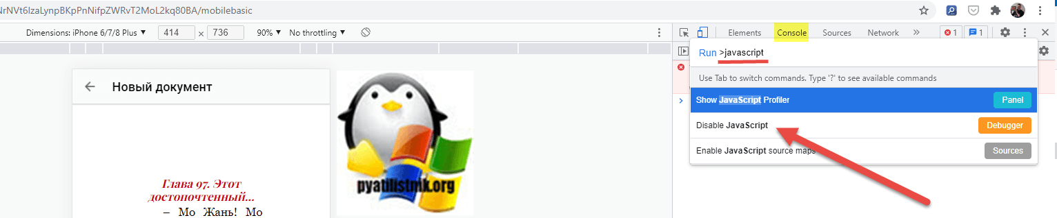](https://pyatilistnik.org/wp-content/uploads/2021/11/successful-download-of-a-protected-document-to-google.png)

После это вставьте на вкладке "Console" вот такой код:

function rtcScript() {  
document.oncontextmenu = null;  
document.onselectstart = null;  
document.onmousedown = null;  
document.onclick = null;  
document.oncopy = null;  
document.oncut = null;  
var elements = document.getElementsByTagName('\*');  
for (var i = 0; i < elements.length; i++) {  
elements[i].oncontextmenu = null;  
elements[i].onselectstart = null;  
elements[i].onmousedown = null;  
elements[i].oncopy = null;  
elements[i].oncut = null;  
}  
function preventShareThis() {  
document.getSelection = window.getSelection = function() {  
return {isCollapsed: true};  
}  
}  
var scripts = document.getElementsByTagName('script');  
for (var i = 0; i < scripts.length; i++) {  
if (scripts[i].src.indexOf('w.sharethis.com') > -1) {  
preventShareThis();  
}  
}  
if (typeof Tynt != 'undefined') {  
Tynt = null;  
}  
}  
rtcScript();  
setInterval(rtcScript, 2000);

После этого вам нужно просто обновить страница, это можно сделать через клавишу F5.

[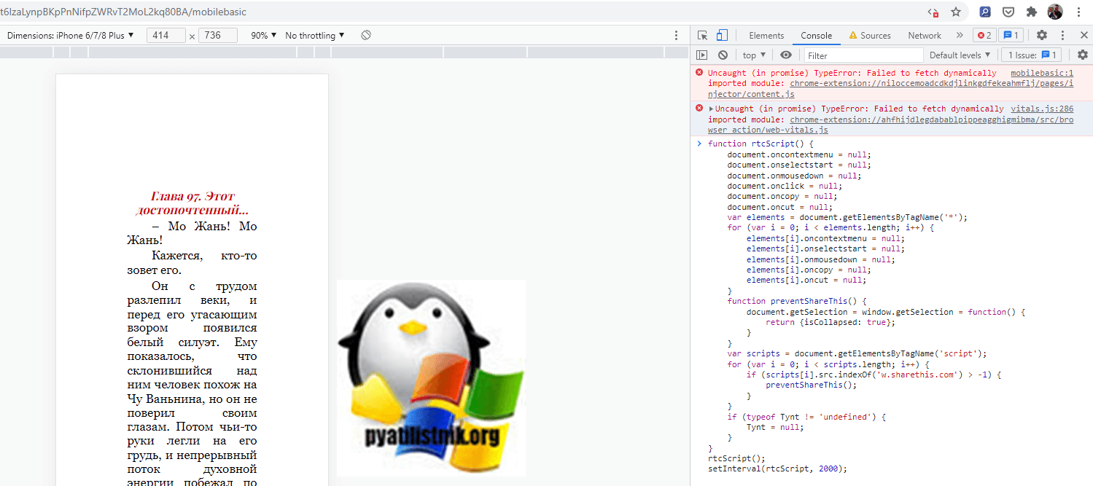](https://pyatilistnik.org/wp-content/uploads/2021/11/downloading-a-protected-document-to-google.png)

Теперь нажмите опять на страница сочетание клавиш CTRL и A, а после этого вставьте выделенный текст в новый Google документ.

[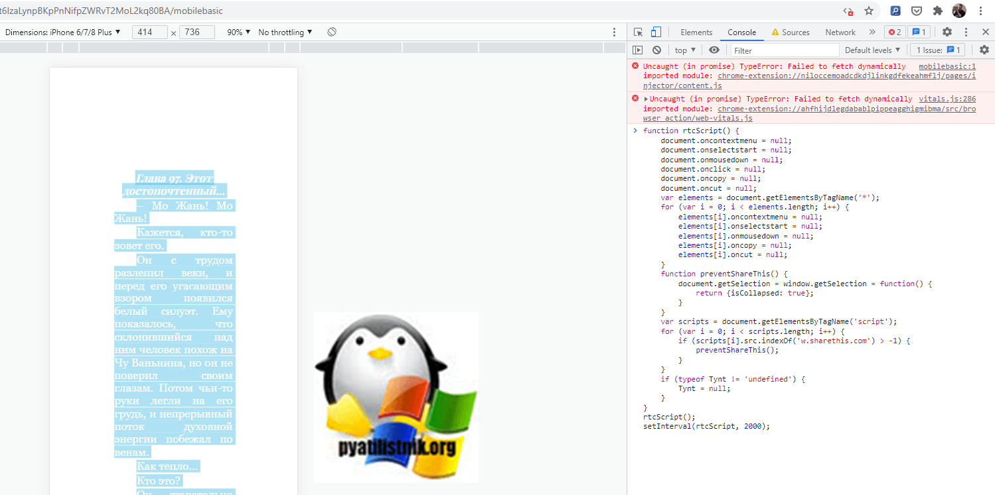](https://pyatilistnik.org/wp-content/uploads/2021/11/uploading-a-protected-document-to-google.png)

Или вы так же тут можете нажать CTRL и P,  где сразу же сможете сохранить защищенный Google документ в формате PDF.

[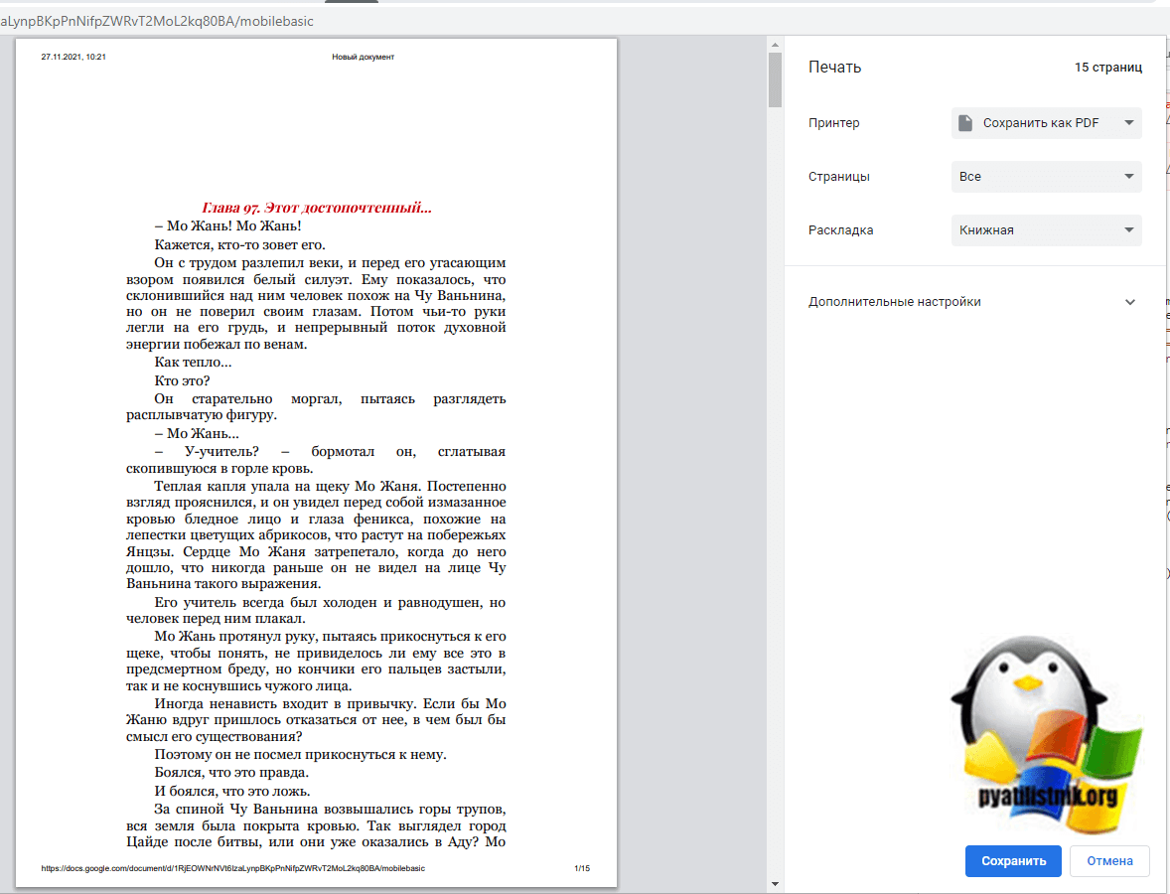](https://pyatilistnik.org/wp-content/uploads/2021/11/uploading-a-limited-document-to-google.png)

Надеюсь, что это для вас оказалось полезным. не забывайте подписаться на мой Youtube и телеграмм канал https://t.me/pyatilistnikorg. С вами был Иван Сёмин, автор и создатель IT портала Pyatilistnik.org.

[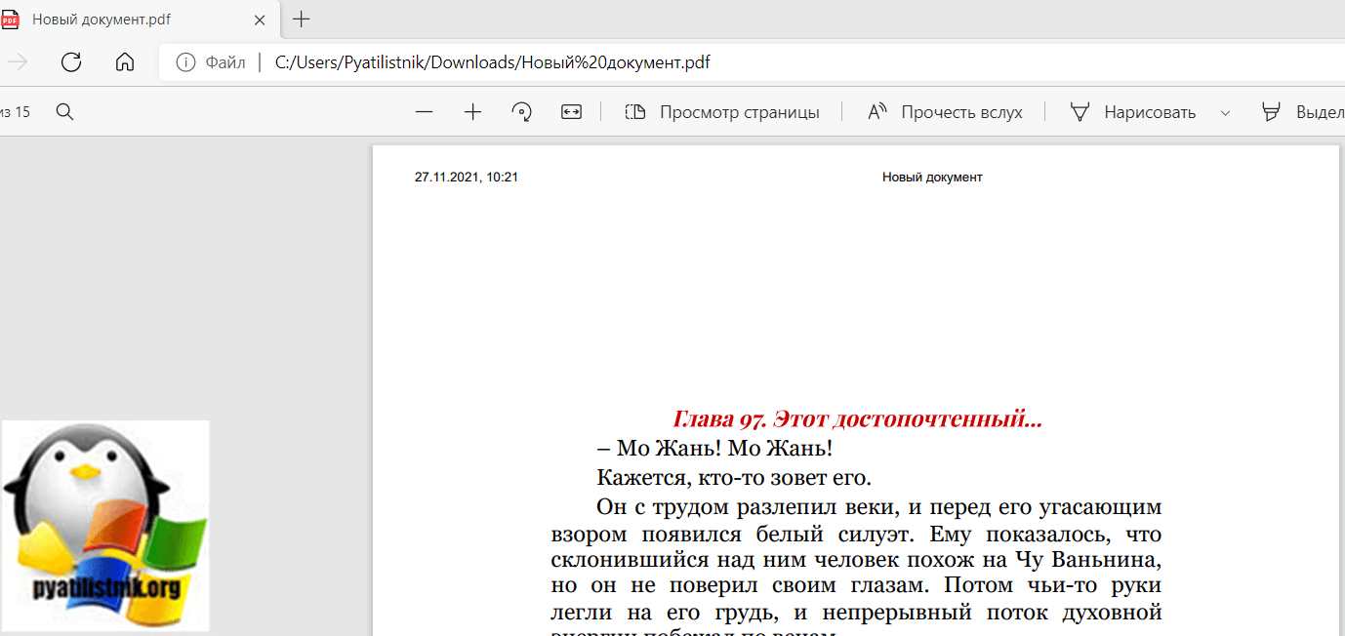](https://pyatilistnik.org/wp-content/uploads/2021/11/downloading-a-limited-document-to-google.png)